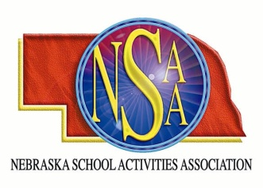

***RULES MEETINGS***

Before gaining access to rules meeting, you must pay the registration fee. The NSAA is offering FREE online rules meetings for a limited time period, which will satisfy the rules meeting requirement for head coaches and judges. During the two week “no charge” period, head coaches and judges can access the online rules meeting using their NSAA passcode.

NEW JUDGES: Go to the NSAA Home Page – Click on the Speech or Play Production link. Refer to the first item in regard to judge’s registration.

Last Year’s NSAA Registered Judges: Go to the NSAA Home Page - Login with your NSAA judge’s passcode. For those individuals that are a Head Speech or Play Production coach AND a Judge - please login with your judges passcode only to view the rules meeting.

ONLINE RULES MEETINGS

October 3 to October 16 No Charge to Judges & Head Coaches

October 17 to October 25 Basic $25 Fee – Judges and Head Coaches

October 26 to October 28 Late/Penalty $50 Fee – Judges and Head Coaches

ON-SITE RULES MEETING SCHEDULE

**September 29, 7:00 pm Norfolk, NSCTA Convention

All judges are welcome to attend the NSCTA rules meeting and judges sessions. Refer to NSCTA.info for registration and schedule.

*Attendance at the NSCTA rules meeting satisfies the judges rules meeting requirement.*

**Questions?**

Speech and Play Production: Contact Debra Velder at:[**dvelder@nsaahome.org**](mailto:dvelder@nsaahome.org)

Judges registration: Contact Cindy Callaway at: [**ccallaway@nsaahome.org**](mailto:ccallaway@nsaahome.org)

Nebraska School Activities Association’s home page address:

**http:\\www.nsaahome.org**